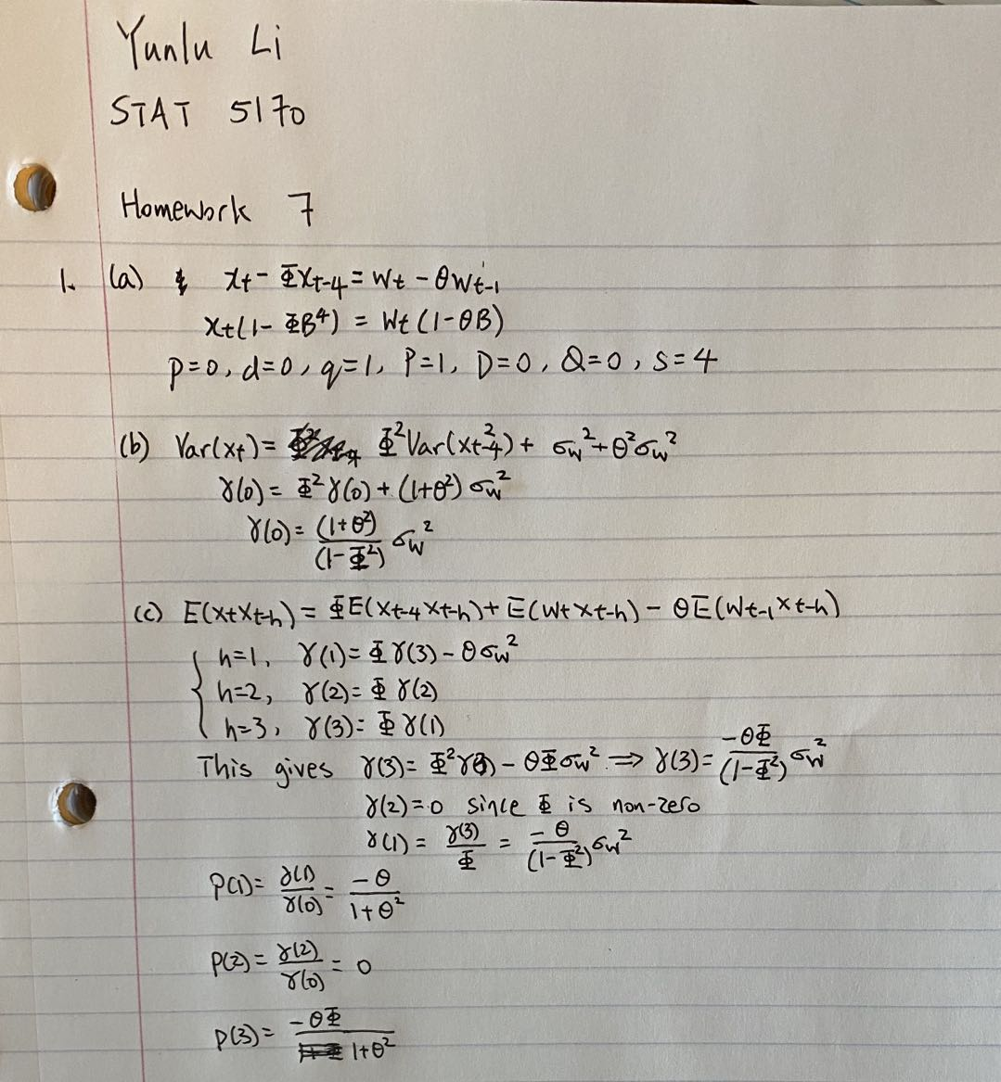

2.

1. Exploratory Data Analysis

The time series of data shows that there appears to be an increasing trend and seasonal trend.

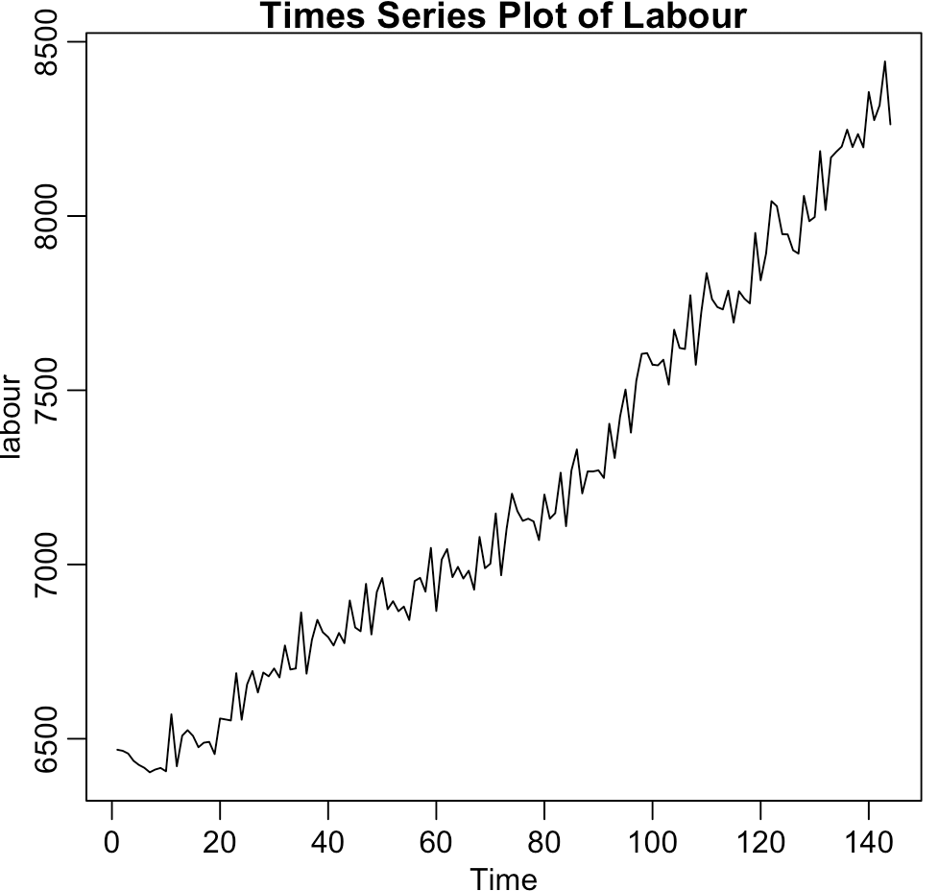

Then we apply differencing and seasonal differencing. The time series, ACF, PACF of the data are shown as follows.

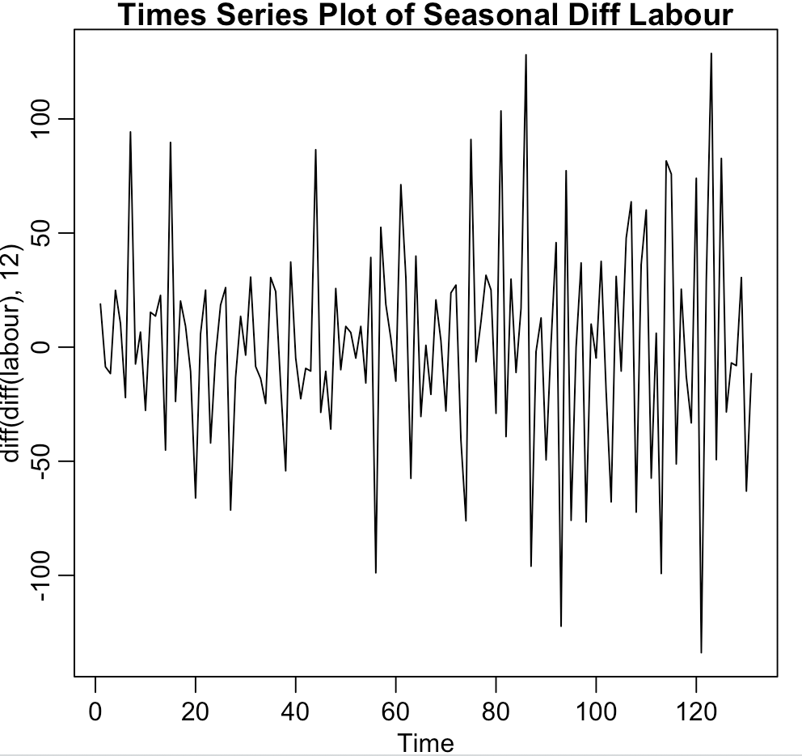 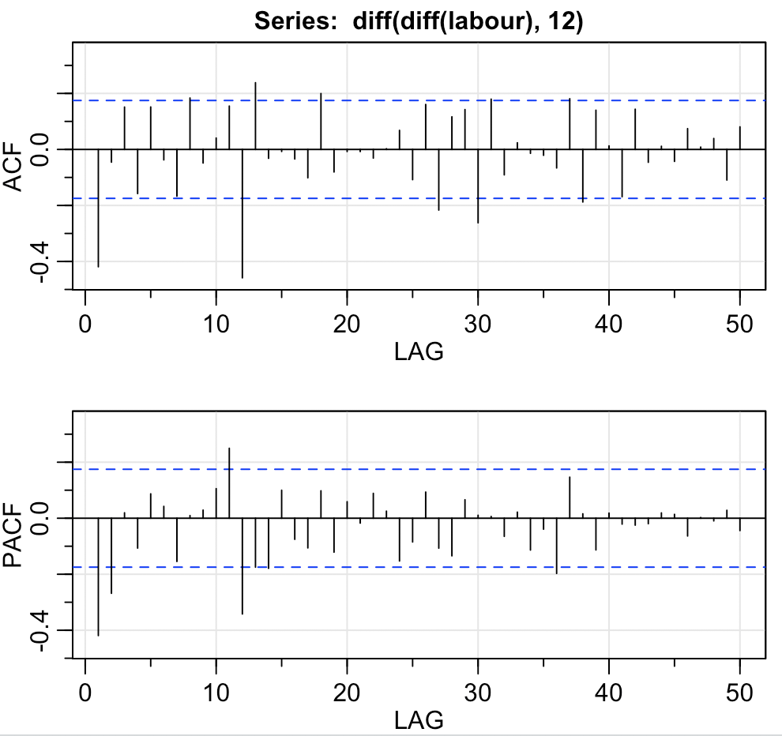

1. Model Fitting.

Since we apply differencing and seasonal differencing, d=1 and D=1.

By looking at lags 12, 24, 36 … of ACF and PACF, we can see P=1 and Q=1.

By looking at lags 1, 2, …, 11 of ACF and PACF, we consider MA(1), AR(2), and ARMA(1,1).

Here are all possible models that we can try:

1. ARIMA(0,1,1)x(0,1,1)12
2. ARIMA(2,1,0)x(1,1,1)12
3. ARIMA(1,1,1)x(1,1,1)12
4. ARIMA(1,1,0)x(1,1,0)12
5. Model Selection.

By going through all models one by one, I found that ARIMA(0,1,1)x(0,1,1)12 passes all diagnostics and has all coefficients significant. It also gives smaller AIC, AICc and BIC.

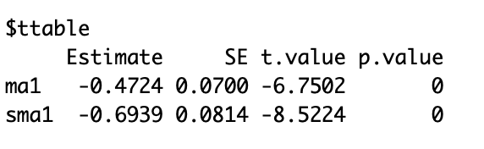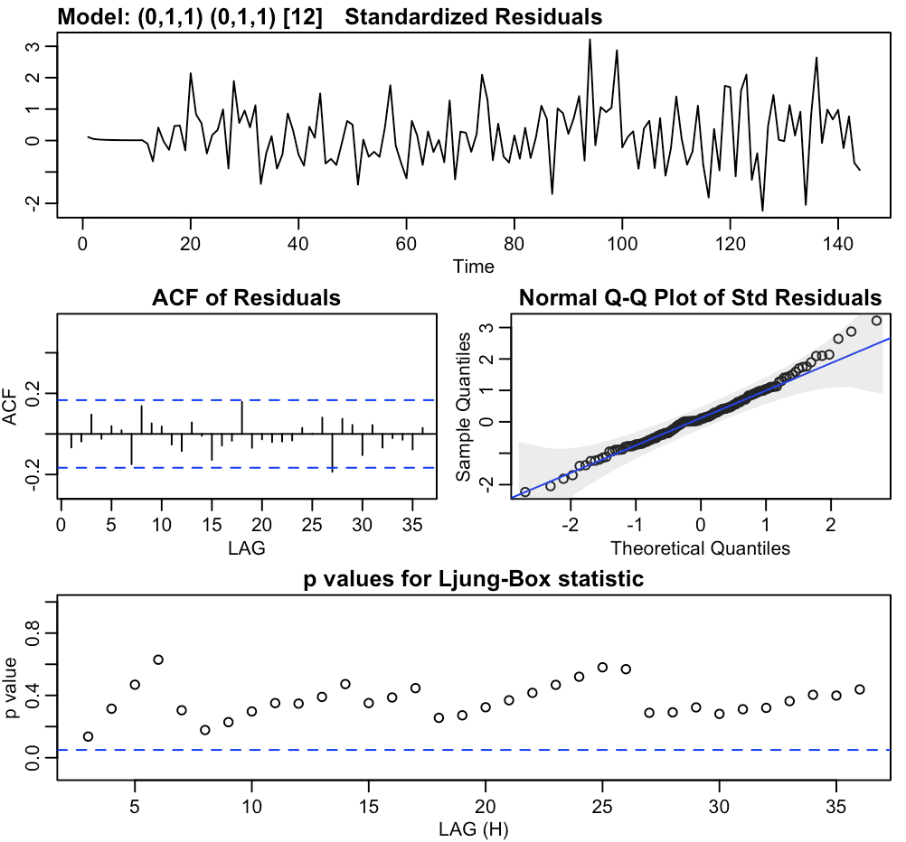

1. Prediction.

As we can see from the table as well as the plot (true observation is blue and prediction is red), there are 9 observations outside the prediction level. This is because there was rather intense recession in 1990-1991. If we use pre-change model to predict forecast post-change values, most values will not make sense because the two parts of data has different model dynamics.

